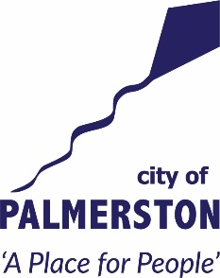

NAIDOC Week 2022 Mural

City of Palmerston

ARTIST EXPRESSION OF INTEREST

City of Palmerston Council are seeking an Expression of Interest from an experienced local First Nations artist for the concept development, design, and production of a Mural to celebrate NAIDOC Week 2022,
The purpose of the project and the mural is to celebrate our local First Nations People through NAIDOC Week and the 2022 theme of ‘Get Up! Stand Up! Show Up!‘ The mural will also enhance our city’s public spaces, expose the community to contemporary art forms, to engage our arts community in meaningful public artwork, and to deter graffiti and vandalism. The mural will be located at the outside basketball court at the Palmerston Recreation Centre in the CBD.
You are invited to submit a concept design for the site with a quote to implement this project. The details for this process and site specifics are outlined in the NAIDOC Week 2022 Mural Artist Brief below. The mural must be completed by Sunday 10th July 2022.

ARTIST BRIEF

Overview
City of Palmerston is looking to celebrate NAIDOC Week 2022 and will engage an artist to produce a mural that responds to the theme of Get Up! Stand Up! Speak Up! and embraces First Nations people’s contribution to the City of Palmerston.

The proposed timeframe would see the artwork installed by 10 July in time for NAIDOC Week 2022.

City of Palmerston will hold an open call out to local artists to produce the work specifically required for NAIDOC Week 2022. It is preferred that the artist will be a First Nations artist with a connection to the Palmerston region.
A panel consisting of internal City of Palmerston staff and external stakeholders will meet to decide on the most suitable application.

Theme
The theme of the mural should align to the project’s purpose to celebrate our local First Nations community through NAIDOC Week 2022 and the 2022 theme of ‘Get Up! Stand Up! Show Up!’ You can read more about the NAIDOC Week 2022 Theme at https://www.naidoc.org.au/awards/current-theme.
The design should consider the following:
- Be an original and innovative design.
- Be vibrant and welcoming.
- Be appropriate for public display to an audience comprising of a range of age groups, and social and cultural backgrounds, including the Aboriginal custodians of the land.
- Be visually and sensitively appropriate to the site.

The mural will enhance our city’s public spaces, expose the community to contemporary art forms, engage our arts community in meaningful public artwork, and deter graffiti and vandalism.

Scope

This project includes artwork development, design and installation of a mural and the artist will be required to execute the design in situ. The budget for the project is up to $10,000 inclusive of GST.

The scope of works includes:
• Design and supply of an artwork
- the design is to consider/respond to the site, place and theme provided
- you will provide two concept artworks for consideration for the review panel
- will allow up to two sets of changes, any further changes can be charged to City of Palmerston
• Supply of all materials required
• Supply and operation of all equipment required
• Preparation of wall for application
• Completion of the works on or prior to agreed completion date

Site
The proposed location of the mural is on the Eastern Wall of the City of Palmerston Recreation Centre Outdoor Basketball Court, 11 The Boulevard, Palmerston, a prominent site within the Palmerston CBD, opposite the City of Palmerston Library (see map and site images below). The site is visible to pedestrian and vehicle traffic. The building is owned and managed by the City of Palmerston.
The artwork is site specific; the treatment must be applied only to the allocated walls/surfaces.

Dimensions of wall (images below)

Approximate Height: 4.7metres (at tallest) and 3.8 metres (at shortest)
Approximate Length: 12 metres
Logistics: Elevated Work Platforms will be required to access the full height of the wall. Submissions will need to include the cost of hire and artists will need appropriate licenses. Council staff can assist in the hiring of this equipment if required.

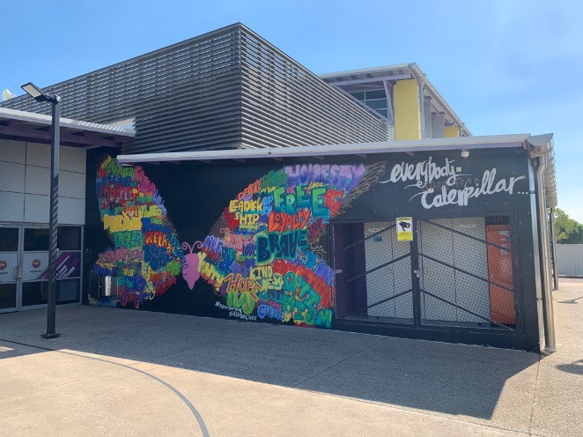
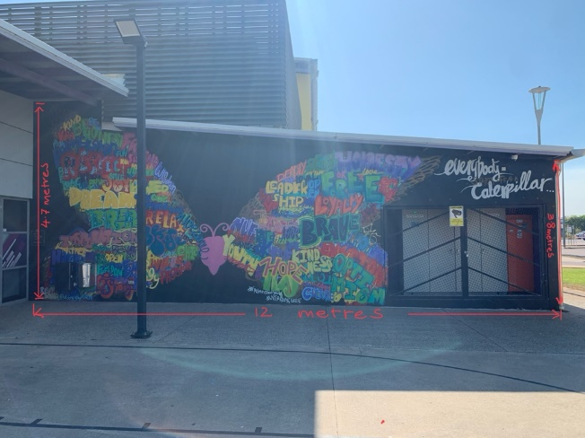

Photos of existing wall

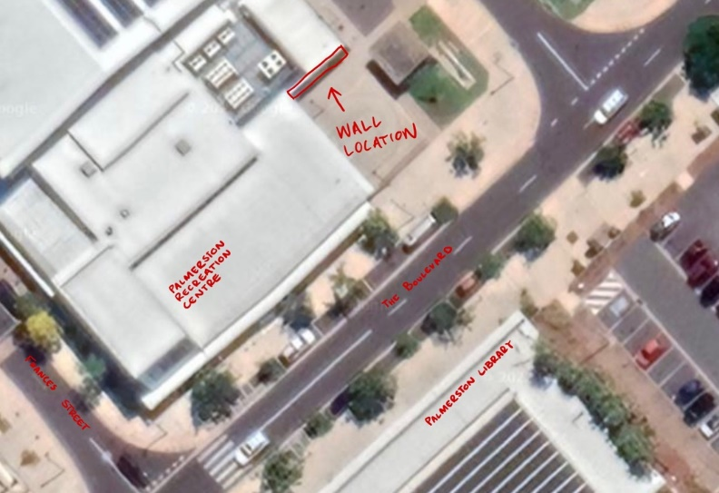

Wall Location on the corner of The Boulevard and Hillson Street, Palmerston

Design Considerations
The intended lifespan of the mural is one to three years, the minimum projected lifespan is one year. In the case of major vandalism, or significant damage from partial demolition or structural repair works to the wall, Council will determine the course of action in consultation with the artist where possible.

The safety of the community is paramount, and the artist must consider all safety standards relevant to art in public spaces. The artwork will have a minimum lifespan of one year, where the Council has discretion to remove the mural or commission a replacement artwork. City of Palmerston reserves the right to remove the artwork at any time without consultation with the artist.

The artist will retain copyright in the work and in any designs created under this Agreement. The artist agrees to permit Council to publish reproductions of the Work for any non-commercial purpose, including Council reports, brochures, tourist information, promotional posters, catalogues, social media and documentary film. Council will acknowledge the Artist as the creator of the Work in all Council publications in which the Works are included.

Materials and Maintenance
Materials are to address Australian Standards, be high quality, durable (to withstand extreme heat/cold) and application and usage to follow recommended WHS processes and procedures. Artists will be encouraged to use environmentally sustainable products and methods where possible.

Artists may utilise design techniques including stencil, painted and/or aerosol work.

Relevant certification must be held by artists using Elevated Work Platforms (eg. scissor/boom lifts, scaffolding, ladders over 2.4 meters in height).

The artwork will be maintained by Council for a minimum period of one year (except in the case of severe damage, see Design Life section). This maintenance cost will be covered by Council.

Parameters
The artwork should not portray or depict material in a way which discriminates against or vilifies a person or section of the community on account of race, ethnicity, nationality, gender, age, sexual preference, religion, disability, mental illness or political belief. It must not contain crude language, depict highly sexual or violent images, or contain personal details.

In addition:
• The artwork cannot be advertising
• The work must be suitable for general audiences
• The artwork should demonstrate artistic excellence

Insurance and Risk Management
Successful artists/teams of artists are required to have/obtain current Public Liability Insurance of $20,000,000. Any additional insurance and risk management requirements will be discussed with the successful applicant.

Fee Schedule
Payment of fees will be made in two stages:
• 50% paid on acceptance of final design, commission of selected artist and signing of the contract
• 50% paid on completion of the artwork and after final inspection and approval by Council

Artist Responsibilities
Council requires the project artist to:
- Manage and deliver the project within the agreed schedule.
- Deliver the agreed design (as approved by Council).
- Work in accordance with best practice community cultural development principles and practices in the consultation, research, creative development and design.
- Consult and liaise with Council staff, subcontractors as required.
- Undertake site visit.
- Remediate the site if required.
- Follow all applicable Occupational Health and Safety (OH&S) Standards.
- Deliver the project in accordance with an agreed set of delivery milestones.
- Delivery of artist statement and availability for media interviews.
- Provide artist statement and be available for media interviews if required

Submission/Quote requirements
A quote is required to respond to the artists brief it should contain the following:
- A Preliminary Design – Sketch of proposed mural design for the site.
- A Budget Breakdown for all expenditure.
- A proposed Timeline showing key milestones
- A Site Plan showing the location of the proposed elements.

If the quote is accepted, the artist will be required to enter into an agreement with the City of Palmerston.
Timeframes
Quote required by 24 June 2022
The indicative key dates for the process are outlined below. Please note these dates are subject to change and installation dates will be discussed with the successful artist.
Task | Timeline | Responsibility
Quote due | 24 June 2022 | Artist
Response to Quote | 27 June 2022 | Council
Artist develops draft design | 30 June 2022 | Artist
Final design sign-off and approval by Council; first payment made (50%) | 1 July 2022 | Council
Installation schedule approved | 1 July 2022 | Council
Installation of artwork | 4 July 2022 - 10 July 2022 | Artist
Sign off of completed work and site | 11 July 2022 | Council
Final payment (50%) | After final inspection and approval | Council

How to apply
Email the following to kyle.walmsley@palmerston.nt.gov.au
- Written Quote with an itemised Budget
- Copy of required certificates/licenses required if need you plan to use an Elevated Work Platform.
- Copy of current public liability insurance certification (to $20 million)
- Due date 24 June 2022
- For any questions please email the above email or call 8935 9952

